Recon Search
Salesforce Installation & User Guide
Version 2.0



Table of Contents
App Details 3
Package Contents 3
Lightning Components 3
Languages 3
Getting Started 3
Product Overview 3
Steps to access Recon Search 4
Prerequisites to use Recon Search: 10
Section 1: Configuring the Metadata API 10
1. Creating a Connected App for Metadata API 10
2. Auth. Provider Creation for Metadata API 12
3. Create Named Credentials for Metadata API 13
Section 2: Configuring the Tooling API 14
1. Creating a Connected App for Tooling API 14
2. Auth. Provider Creation for Tooling API 16
3. Create Named Credentials for Tooling API 16
What is Recon Search? 18
Additional Features in Recon Search: 22
1. Save: 22
2. Open All : 25

App Details
Version Name: ver 1.0
First Release: 7/3/2024
Latest Release: 7/3/2024

Package Contents
Custom Objects: 2
Custom Tabs: 2
Custom Apps: None
Connected Apps: 2

Lightning Components
Global: None
App Builder: 1
Community Builder: None

Languages
English

Getting Started
Recon Search is a Salesforce solution designed to dynamically render user interfaces in Salesforce Lightning Web Components (LWC) and provide enhanced search capabilities. This solution leverages various components, including a Python script, Apex controllers, and LWC, to facilitate a robust, interactive search experience within Salesforce.

Product Overview
Recon Search is an enhanced search application built within the Salesforce platform. With the help of this app, users can search the records of both standard and custom objects and their related lists in the org globally or specific to the object record based on their own requirements. Additional features include:
- Save and load the search criteria for quick access.
- View all the searched records directly from the component.
- Flexibility to add new custom fields.

Steps to access Recon Search
Step 1: As a first step, install the Recon Search package into your Salesforce org.
Step 2: Assign the package licenses to the required users in the Salesforce org.
Step 3: From the App Launcher, open any of the standard or custom object records where you want to use the search functionality and check whether the Recon Search component is available on the page. NOTE: Task and Case Objects are not currently supported but may be added to a future release.
Step 4: If the component is unavailable on the page, follow the steps below to add it; otherwise, skip to step 8.
Step 5: Click on the Gear icon of the page and then click on the Edit Page option.
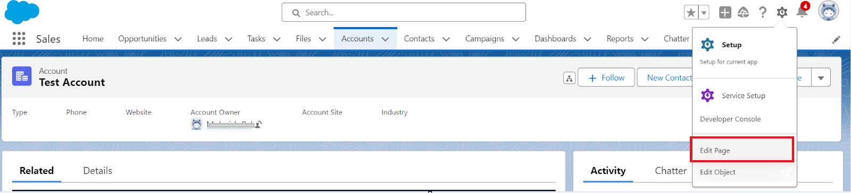

Step 6: Drag the reconSearch custom component from the components list to the desired position on the record page.
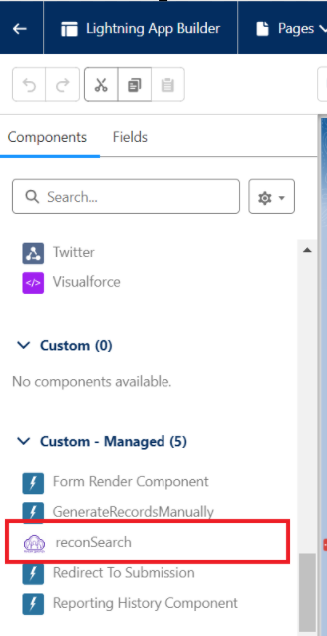

Step 7: Here, you need to pass the lightning page name so that when you add the same component to a different page layout, you have the facility to select a different page layout.
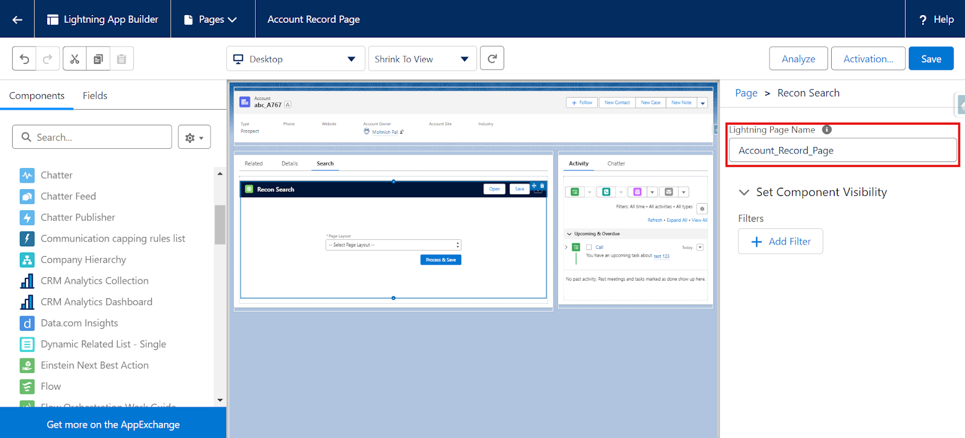
Step 8: Save the changes, then return to the record page. Activation of the Lightning Page may be required if you have not previously done so. Follow the on-screen prompts to activate the page. Clear your browser's cache and reload the page if you still do not see the component. It can take a few minutes for the changes to reflect on the UI.
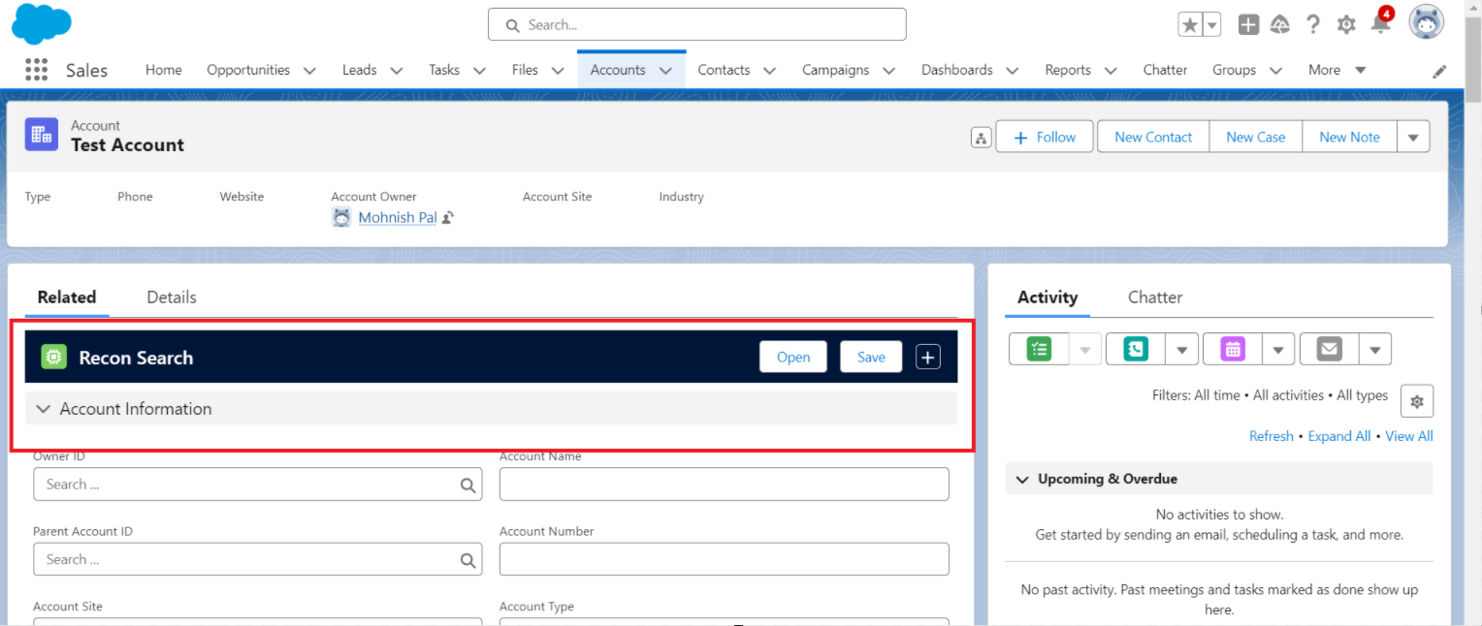
Configuring Search Component for the home page.
The reconSearch component can be placed on the home page or any app page. Here we are providing the steps that should be followed to place the component on the home page.
- Go to any home page or app page where you want to place the search component. In this example, we have opened our default home page.
- Click on the Gear icon and click the “Edit Page” action.
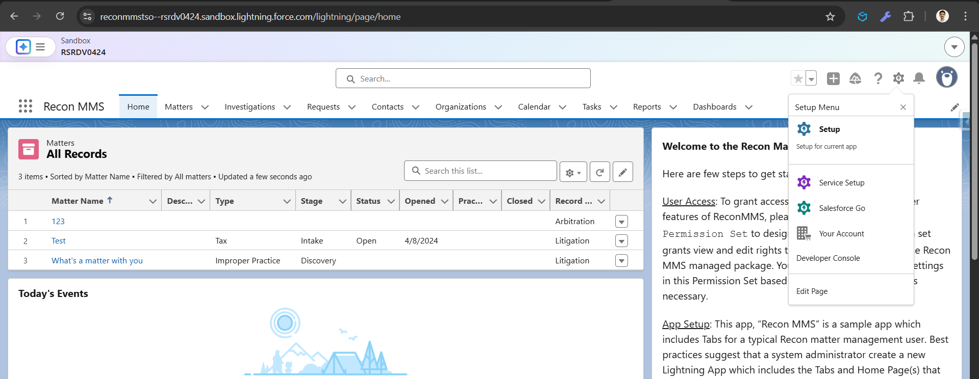
- Here you need to search the “Recon Search” component on the left side panel.
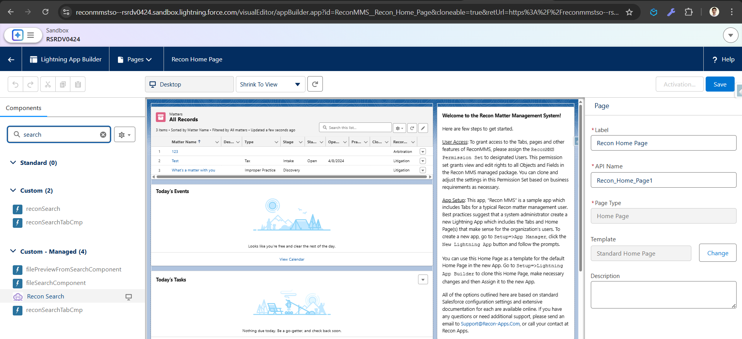
- Drag that component to the page.
- As we dropped the component on the page, you can see it is showing the error, as we need to pass some details to the component. Here, we need to provide the following details
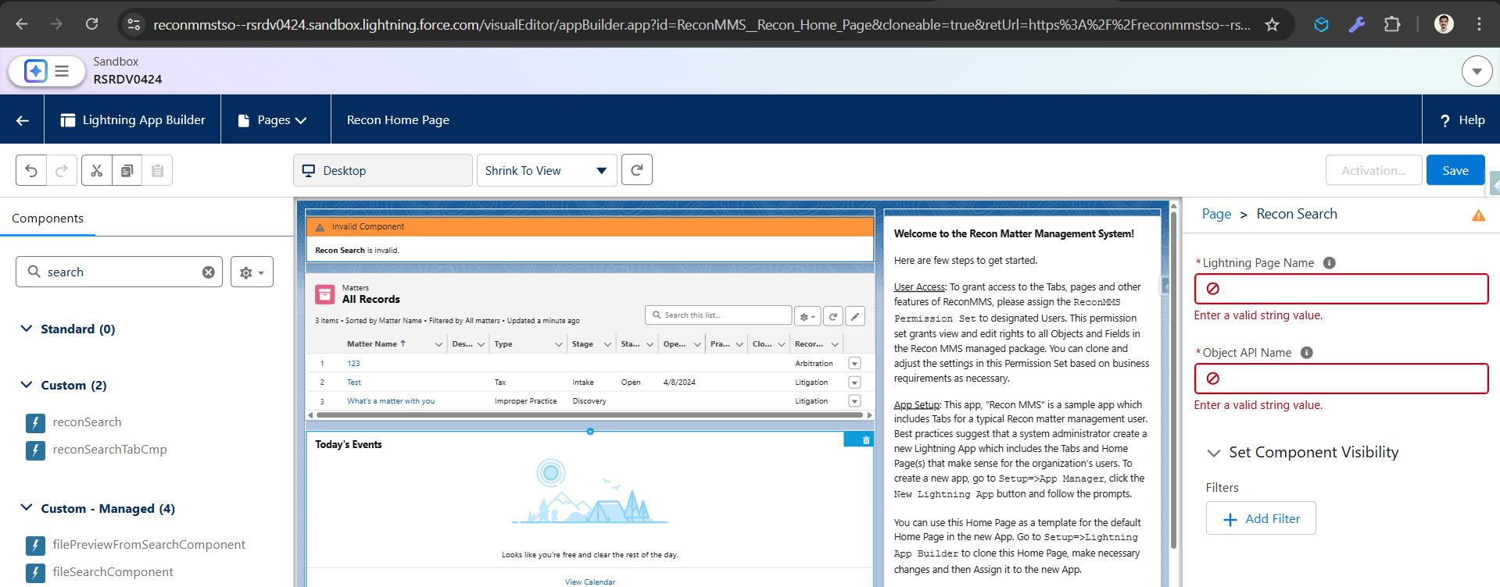
  - Lightning Page Name: You can use the same lightning page name or any other name.
  - Object API Name: Qualified object API name on which you want to perform the search action.
- As you can see, I want to configure the search component for the “Contact” Object, so I have provided the required details.
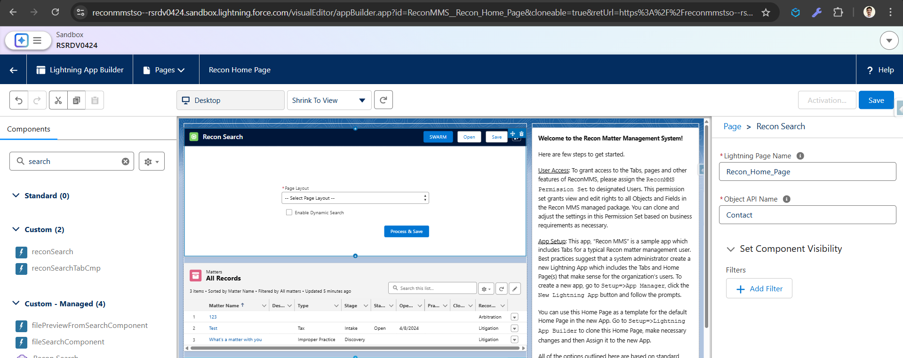
- After providing the details, component will be activated and error will be cleared. Now you should save the changes to access this on home page. Please follow the remaining steps that is required to save the changes.
- As you can see, the component is ready for use. The remaining steps are the same.
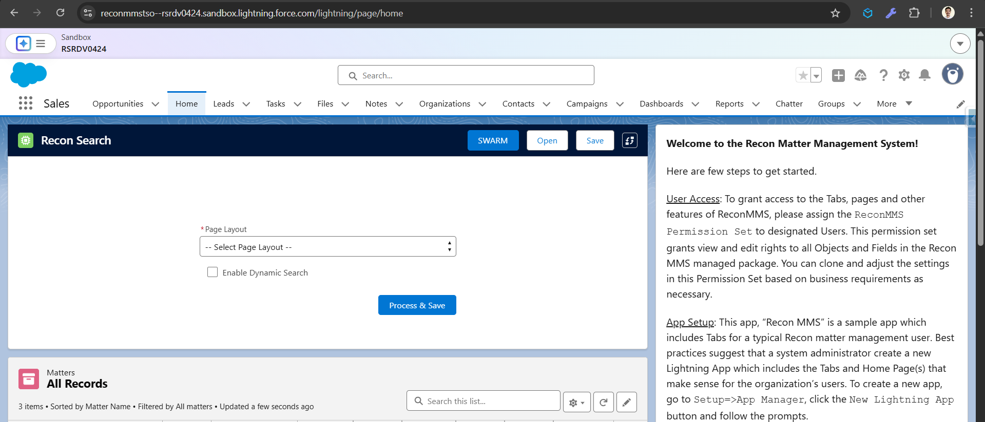

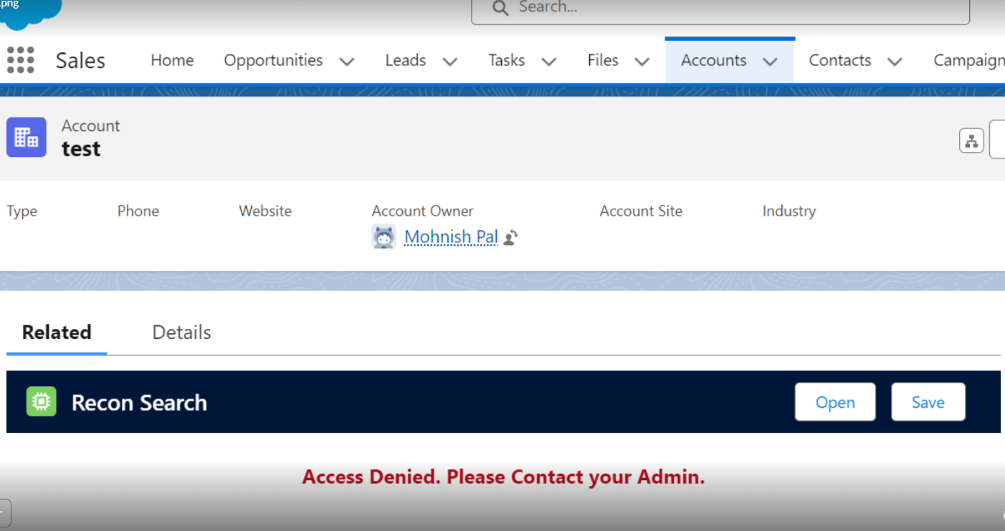
If you see this message, you need permission to access the feature of this component.
For that, you should go to the setup
- Search for the permission set
- From the list, search for "Recon Search Admin."
- Open that permission set
- Click on Manage Assignment
- Add Assignment
- Search for the user from the list and select
- Click on Next
- Click on Assign
- Click on Done
Navigate to your component and refresh the page to see the changes.
When you try to change the page layout and follow the steps to do so but are stuck on this screen, your authorization credentials have expired. You need to authorize yourself to change the page layout.
1. Search for Named Credentials
2. Open the "Recon Search Metadata API"
3. Click on edit
4. Just save and follow the authorization process.
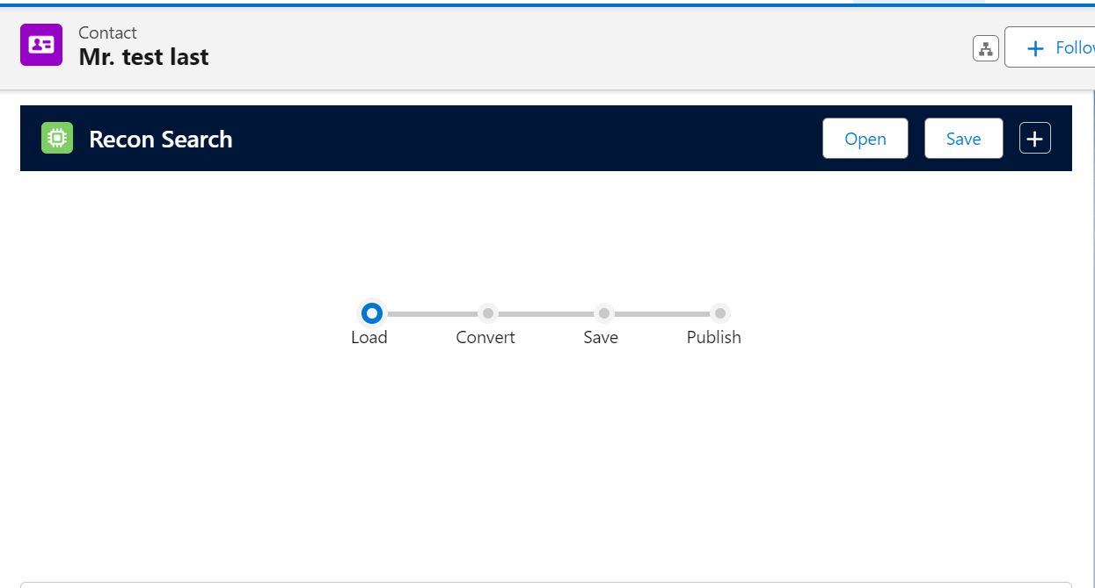
Just select the layout from the list, click on the button below, and if the process is not moving forward, then you need to authorize yourself.

Prerequisites to use Recon Search:
Please complete the prerequisites below before using Recon Search for optimal results.

Note: As this is a one-time process, either the system administrator or a user with appropriate permissions can complete the prerequisites by following the steps below.

Section 1: Configuring the Metadata API

1. Creating a Connected App for the Metadata API
Step 1: From the Setup, type App Manager in the search box and select the App Manager from the list of results.
Step 2: Click the New Connected App button.
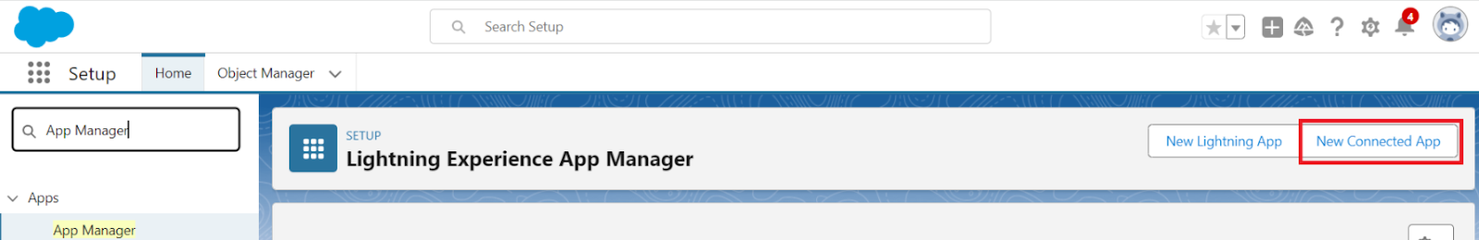
Step 3: For the App Name, enter Recon Search Metadata API and the API name as Recon_Search_Metadata_API.
Step 4: In the Callback URL field, add the callback URL copied from Step 10 of the Auth. Provider Creation for the Metadata API section below.
Step 5: Enable the Enable OAuth Settings checkbox.
Step 6: Choose the “full” and “refresh_token, offline_access” OAuth Scopes, as shown in the figure below.
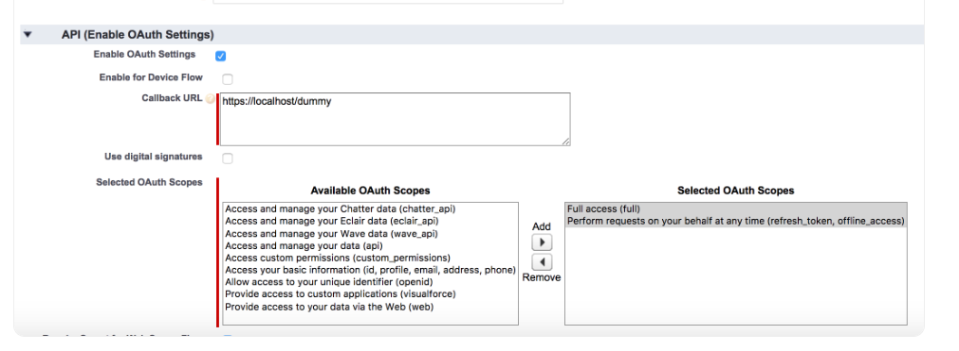
Step 7: Enable the Require Secret for Refresh Token Flow checkbox.
Step 8: Enable the Enable Refresh Token Rotation checkbox.
Step 9: Save the connected app and make a note of the Consumer Key and Consumer Secret that are generated; You will need to use these in the next step..
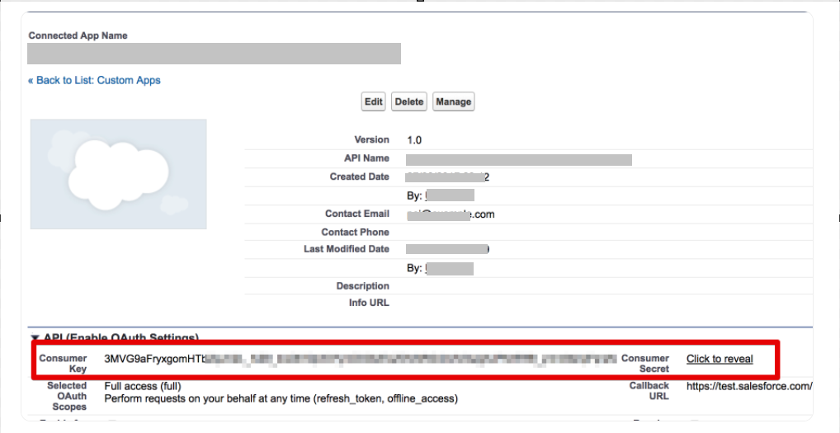

2. Auth. Provider Creation for Metadata API
Step 1: From the Setup, in the search box, type “Auth.” and then select the Auth. Providers from the list below the search box.
Step 2: Click the New button.
Step 3: Select the Salesforce option in the “Provider Type” dropdown field.
Step 4: For your Auth. Provide a name, enter Recon Search Metadata API, and set the URL Suffix as Recon_Search_Metadata_API.
Step 5: Paste the Consumer Key and Consumer Secret generated in Step 9 of the “Creating a Connected App for Metadata API” section above.
Step 6: Enable the Use Proof Key for Code Exchange (PKCE) Extension checkbox.
Step 7: Add the Default Scopes as refresh_toke,n full offline_access API
Step 8: Enable the Include Consumer Secret in SOAP API Responses checkbox.
Step 9: Save the Auth. Provider.
Step 10: Copy the Callback URL from the “Salesforce Configuration” section.
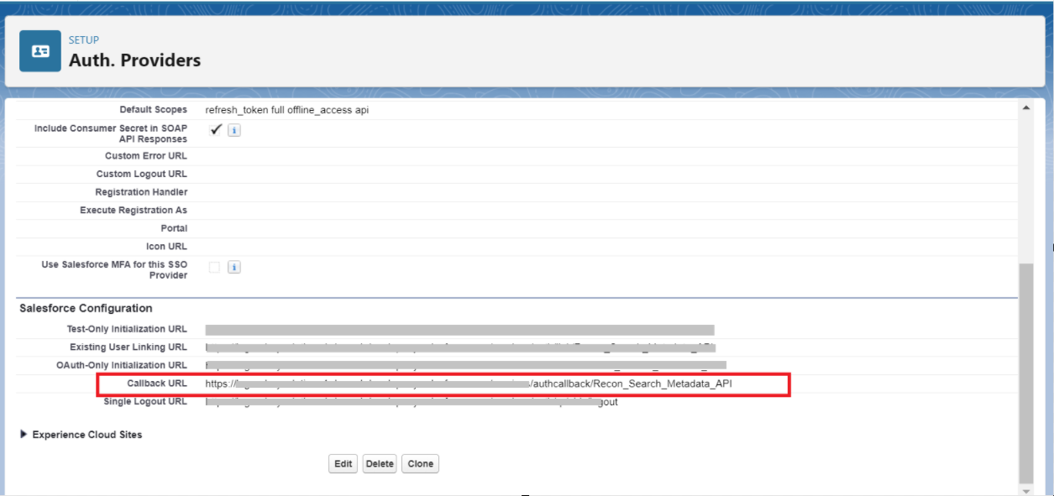

3. Create Named Credentials for the Metadata API
Step 1: From the Setup, in the search box, type named credential and select Named Credentials from the list below the search box.
Step 2: Click on the New Legacy button from the dropdown of the Named Credentials section, as shown below.
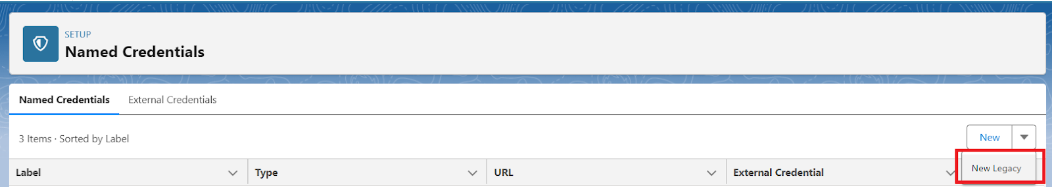
Step 3: Input the Name as Recon_Search_Metadata_API and Label as Recon Search Metadata API.
Step 4: In the URL field, enter your org’s instance URL – this will be the URL for your instance (e.g., na1.salesforce.com), or if you are using My Domain, your fully qualified My Domain domain (e.g., mycompany.my.salesforce.com).
Step 5: Under the Identity Type field, choose Named Principal from the drop-down list.
Step 6: Choose OAuth 2.0 in the drop-down list of Authentication Protocol.
Step 7: In the Authentication Provider field, choose the Recon Search Metadata API Auth. Provider created above.
Step 8: Add the Scope as: refresh_token full offline_access
Step 9: Enable the Start Authentication Flow on Save checkbox.
Step 10: Enable the Generate Authorization Header checkbox.
Step 11: Enable the Allow Merge Fields in HTTP Body checkbox.
Step 12: You will be prompted to log in to your org. After you log in, you will see the connected app authorization screen.
Step 13: Allow access to this app (your app). Once complete, you should be redirected to the Named Credential screen and see that the status is now “Authenticated as….”
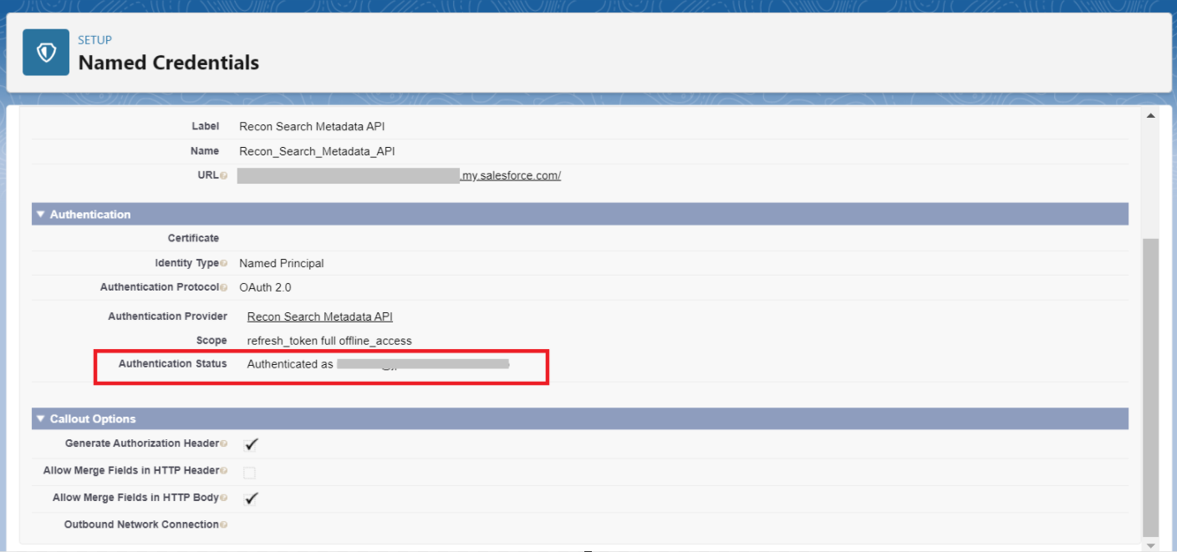

Section 2: Configuring the Tooling API

1. Creating a Connected App for Tooling API
Step 1: From the Setup, type App Manager in the search box and select the App Manager from the list below the search box.
Step 2: Click the New Connected App button.

Step 3: Input the app a name as Recon Search Tooling API with an API Name of Recon_Search_Tooling_API.
Step 4: In the Callback URL field, add the callback URL copied from Step 10 of Auth. Provider Creation for Tooling API section below.
Step 5: Enable the Enable OAuth Settings checkbox.
Step 6: Choose the “full” and “refresh_token, offline_access” OAuth Scopes as shown in the below fig.

Step 7: Enable the Require Secret for Refresh Token Flow checkbox.
Step 8: Enable the Enable Refresh Token Rotation checkbox.
Step 9: Save the connected app and make a note of the Consumer Key and Consumer Secret that are generated; we’ll need to update them in Auth. Providers next..


2. Auth. Provider Creation for Tooling API
Step 1: From the Setup, in the search box, type “Auth.” and then select the Auth. Providers from the list below the search box.
Step 2: Click the New button.
Step 3: Select the Salesforce option in the “Provider Type” dropdown field.
Step 4: Give your Auth. Provider a name as Recon Search Tooling API and URL Suffix as Recon_Search_Tooling_API.
Step 5: Paste the Consumer Key and Consumer Secret generated & saved in Step 9 of the “Creating a Connected App for Tooling API” section above.
Step 6: Enable the Use Proof Key for Code Exchange (PKCE) Extension checkbox.
Step 7: Add the Default Scopes as: refresh_token, full offline_access
Step 8: Enable the Include Consumer Secret in SOAP API Responses checkbox.
Step 9: Save the Auth. Provider.
Step 10: Copy the Callback URL from the “Salesforce Configuration” section.
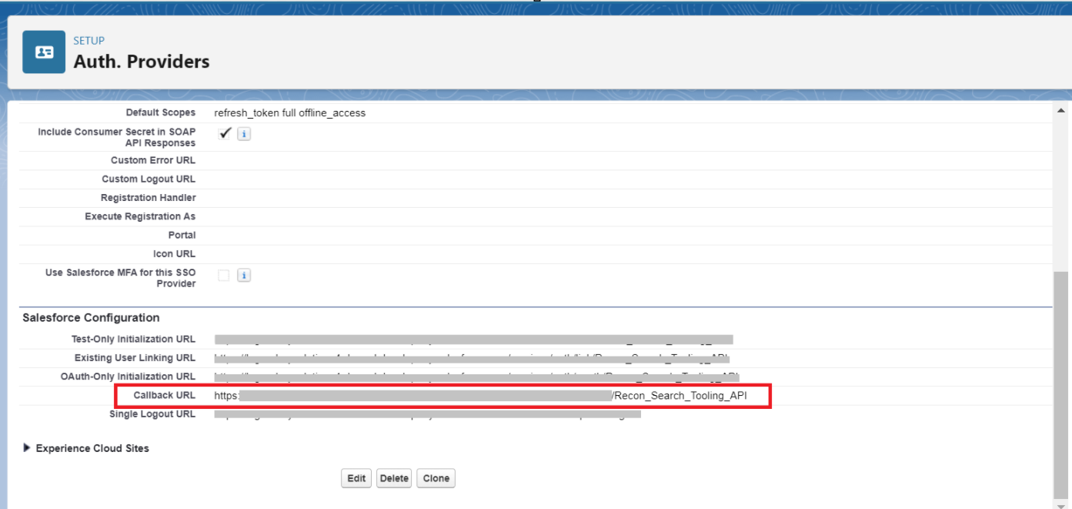

3. Create Named Credentials for Tooling API
Step 1: From the Setup, in the search box, type named credential and then select the Named Credentials from the list below the search box.
Step 2: Click on the New Legacy button from the dropdown of the Named Credentials section, as shown below.

Step 3: Input the Name as Recon_Search_Tooling_API and Label as Recon Search Tooling API.
Step 4: In the URL field, enter your org’s instance URL – this will be the URL for your instance (e.g., na1.salesforce.com), or if you are using My Domain, your fully qualified My Domain domain (e.g., mycompany.my.salesforce.com).
Step 5: Under the Identity Type field, choose Named Principal from the drop-down list.
Step 6: Choose OAuth 2.0 in the drop-down list of Authentication Protocol.
Step 7: In the Authentication Provider field, choose the Recon Search Tooling API Auth. Provider created above.
Step 8: Add the Scope as: refresh_token full offline_access
Step 9: Enable the Start Authentication Flow on Save checkbox.
Step 10: Enable the Generate Authorization Header checkbox.
Step 11: Enable the Allow Merge Fields in HTTP Body checkbox.
Step 12: You will be prompted to log in to your org. After you log in, you will see the connected app authorization screen.
Step 13: Allow access to this app (your app). Once complete, you should be redirected to the Named Credential screen and see that the status is now “Authenticated as….”
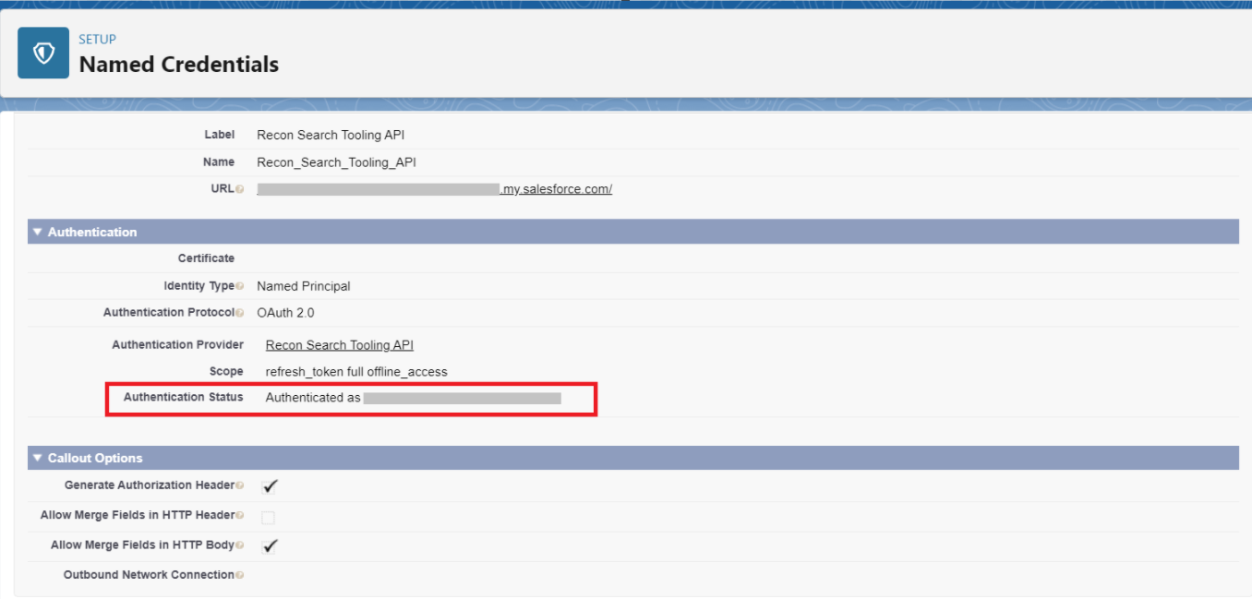

What is Recon Search?
Recon Search is a custom component created within the salesforce application that helps to get a list of records that matches the search criteria added by the user in the custom or standard object fields available in the component.

How to Use Recon Search:
- The Recon Search component consists of two parts:
1. Record - Details
2. Related Lists
- Recon Search uses a page layout to display fields in the Record Details section and related objects in Related Lists.
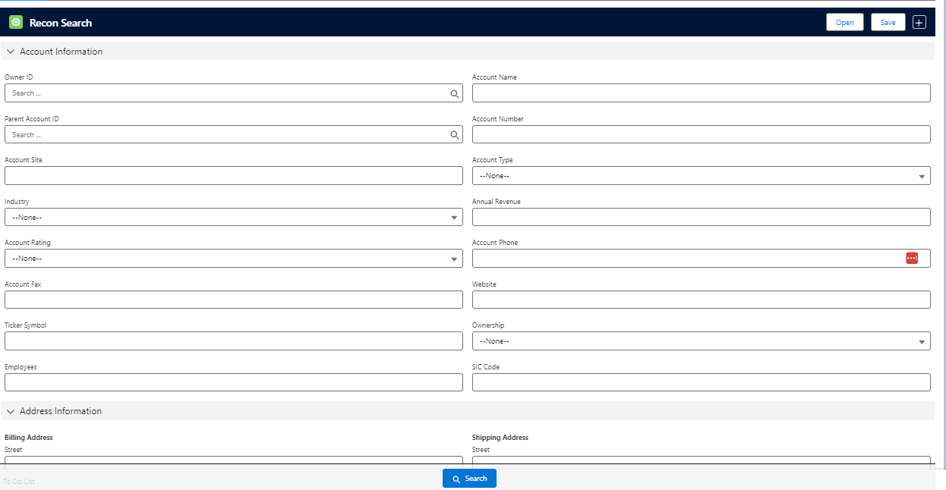
Step 1: Open the object record where the Recon Search component is already added.
Step 2: Click on ‘+’ symbol to get the page layout selection window.
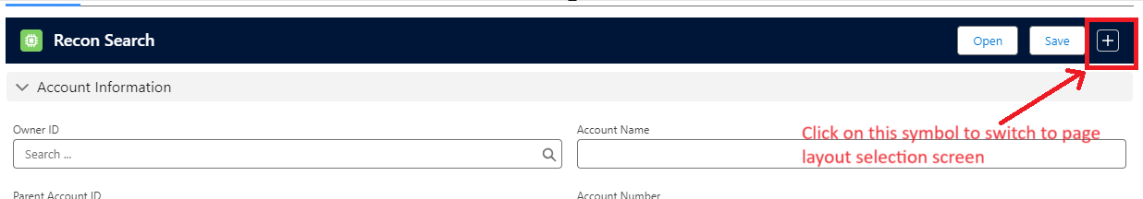
Step 3: Select the required page layout of the object from the drop-down menu.
Note: The Recon Search component only accesses fields and Related lists added to the page layout. To add or remove fields as search inputs, edit the selected page layout. Be mindful that your changes may impact users if the selected page layout is assigned for use at the record level. For this reason, we suggest creating page layouts specifically for use in Recon Search.

Step 4: Click on the Process & Save button.
Step 5: Now, you can add your search keyword to the respective fields of the object (e.g., Account) and click on the Search button to get a list of records matching your search criteria.
Ex: User wants to see how many account records are available in the org with the Account Name as Test.
Solution: In the Recon Search component, add the test keyword in the Account Name field and click on the Search button.
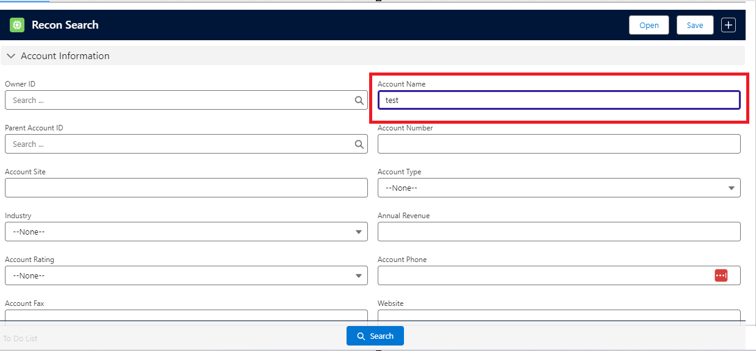

You’ll see a list of account records that start with “test” on top of the component, as shown below:
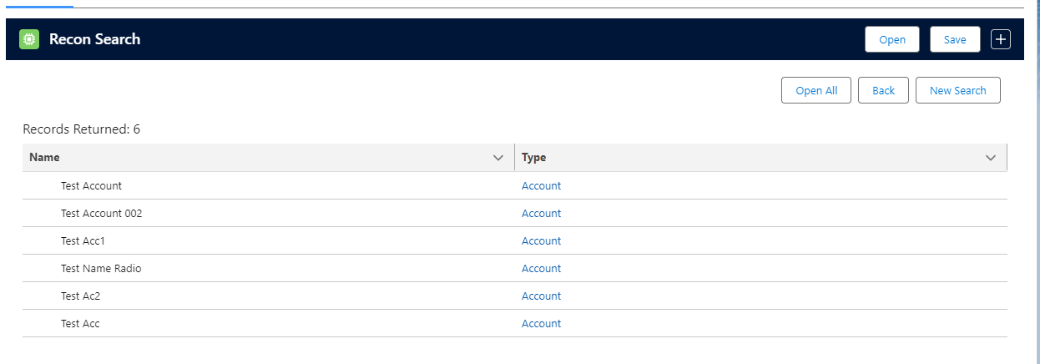
Step 6: Not only can users search the object(e.g, Account) records, but they can also search related objects(e.g, contacts, opportunities) records added in the page layout selected in Step 3 from the same page by adding the search keywords in the related list fields as below:
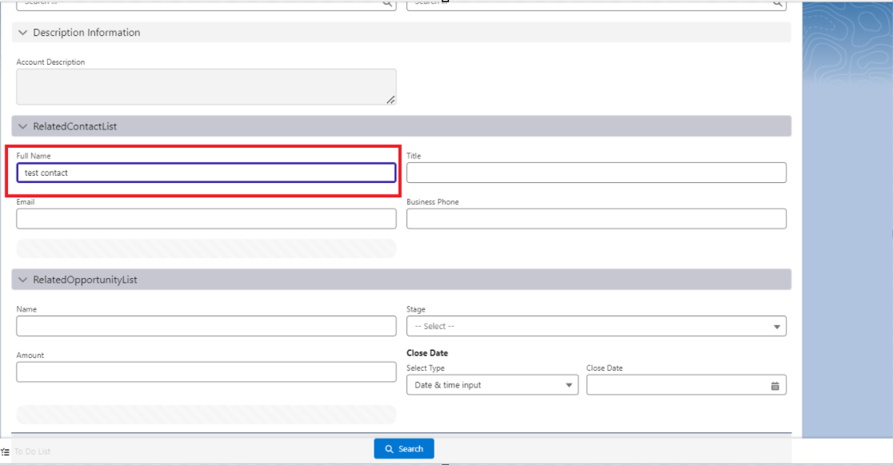

Result:
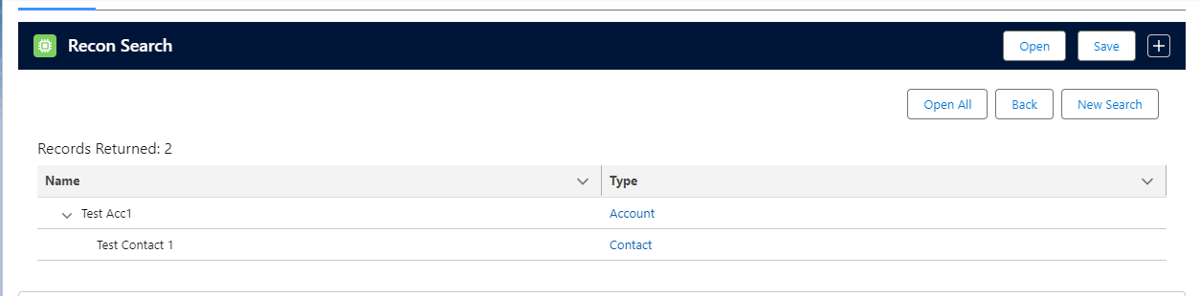

How Recon Search Works:
Recon Search works on a logical ‘AND’ operation while searching the records. Future iterations may enhance this to include ‘OR’ and combined ‘AND/OR’ logic, but is not currently supported.

Scenario 1: If users enter multiple search conditions in the record detail section of the Recon Search component, then Recon Search runs in logical “AND” on the conditions (search criteria) added in the detail section while performing the search operation.
Scenario 2: The user added multiple search conditions in the record detail section and search condition/s in related lists. Then, the user reconfigured the search results for the records by running a logical ‘AND’ on the conditions added in the detail section, which further performed the logical ‘AND’ on the condition/s added in the related lists section.

Use Case 1: The user wants to find all the Account records whose Account names start with Test, the Industry is Other, and the Account Type is Prospect.
Solutions: Go to the Recons Search component added to the account record page, and add the search keywords in the respective fields; as Recon Search uses the ‘AND’ operation while searching, you will get the list of account records that start with test Account Name and its Industry is Other and Account Type is Prospect.

Use Case 2: The user wants to find the Contact (Related list object) records with a Full Name as Test Contact under the Account record with an Account name starting with Test, Industry is Other, and Account Type is Prospect.
Solutions: Go to the Recons Search component added in the account record page, add the search keywords of the account in the respective fields under the detail section, add the keyword Test Contact in the Full name field of the Contact Related list, click on search results the list of account record start with test Account Name and its Industry is Other and Account Type is Prospect along with the contact record with Full Name Test Contact that belongs to the above account.

Additional Features in Recon Search:
In addition to the search functionality, Recon Search provides the ability to save the search criteria added in the component for future use. Users can also open all the search result records in different tabs with a single click instead of finding and opening them from the list of records in the org.

Save :
With this feature, users can save the search criteria added in the component for quick access.
Step 1: Go to the Recons Search component added to the object (e.g., Account) record page, and add the search keywords in the respective fields under the detail section and in the related list fields.
Step 2: Click the Save button. A pop-up window will appear with all the conditions added to the component.
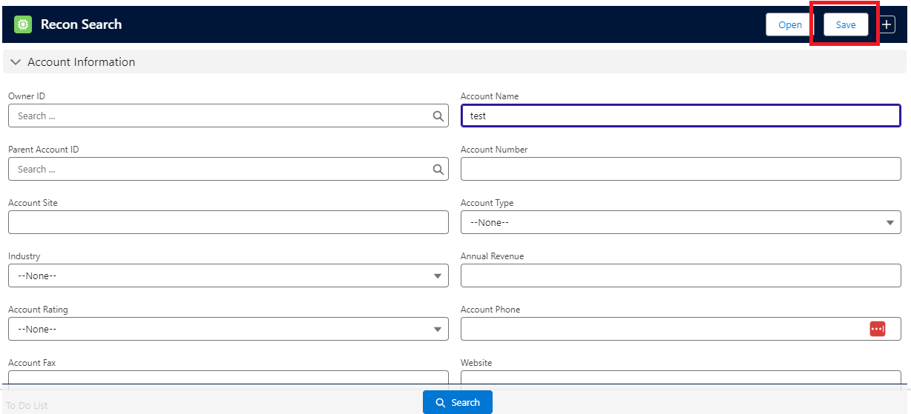

Step 3: Add the relevant name to the criteria and click on the Save button.
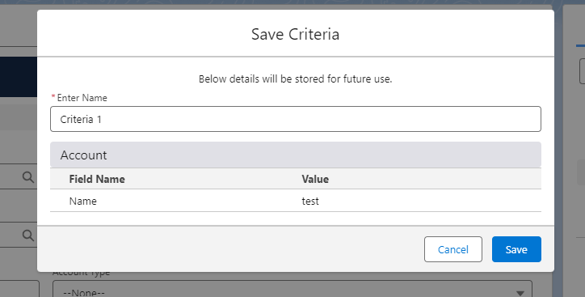

Step 4: To open the saved criteria records, click the Open button.
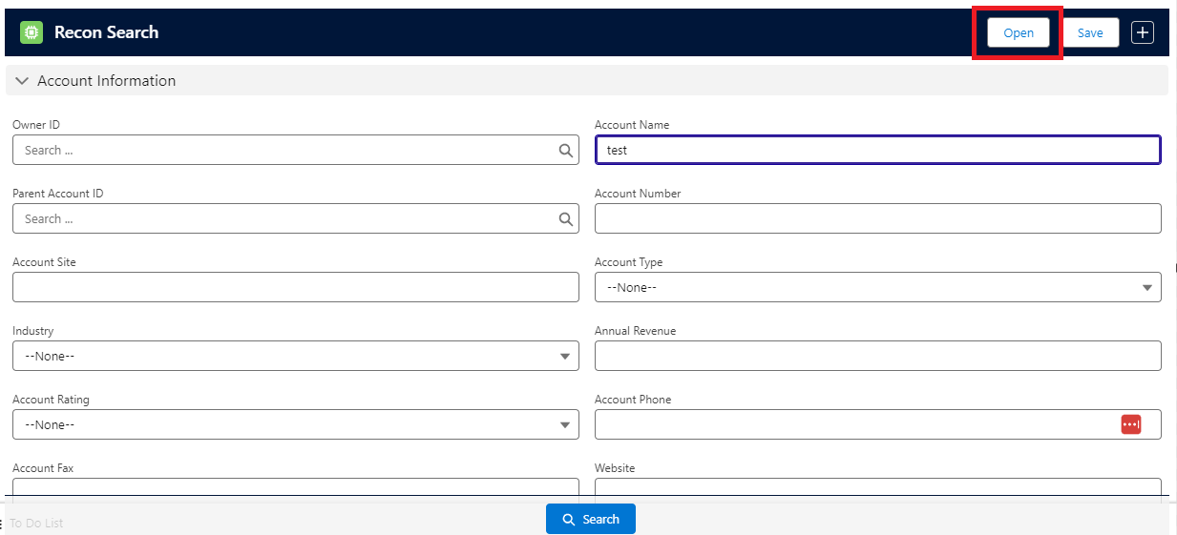

Step 5: Select the saved record from the list.
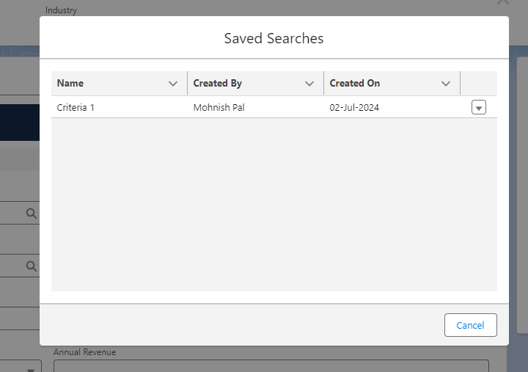

Step 6: Click on the Open button from the drop-down list to load the data for search.
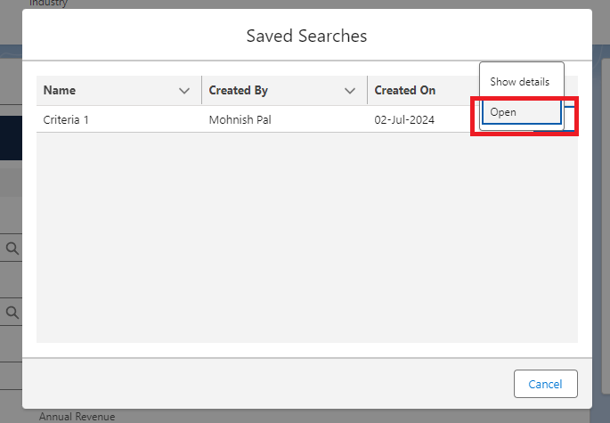

Open All :
With this feature, users can open all the search result records in different tabs with a single click instead of finding and opening them from the list of records in the org.
Step 1: Click on the Open All button.
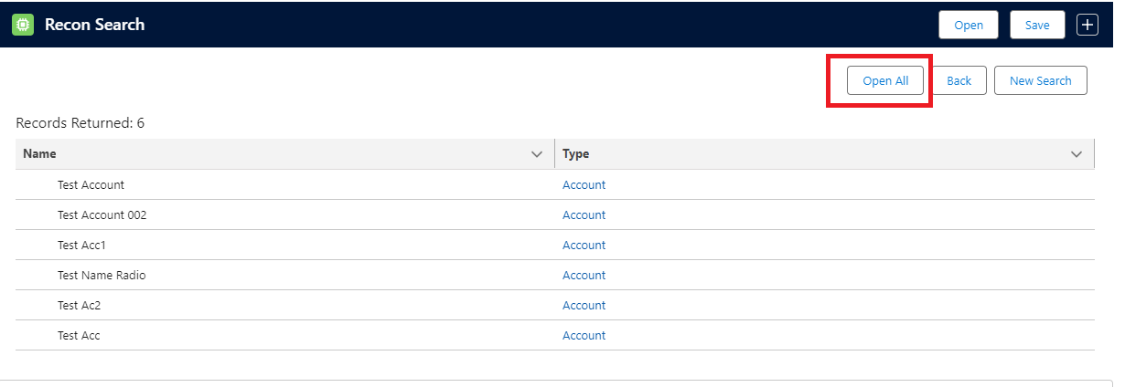

Step 2: A pop-up window will appear with the list of records returned from the search operation.
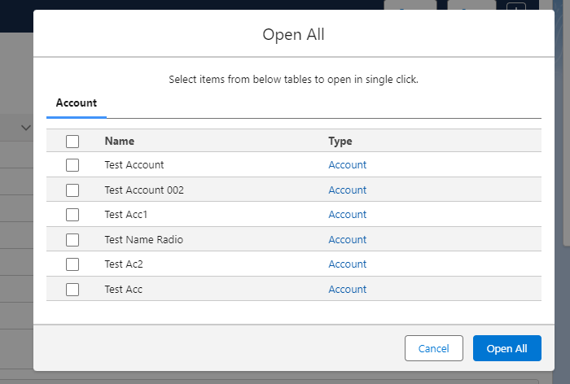
Step 3: Select the checkbox beside the records in the list to open and click on the Open All button. All selected records will open in a new window for each.

